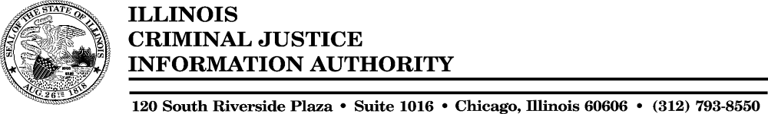

Memorandum

To: Authority Members
From: Jan M. Oncken
Date: August 24, 2004
Re: Summary of Human Resources Activities
The following highlights the work performed by Human Resources since the last Authority meeting.

Recruitment, Screening and Hiring

Activities in this area were extremely busy due to the passing of the FY05 budget and the subsequent approval to post several vacant positions. Additional Personnel Action Request Forms were submitted to the Office of Management and Budget (OMB) and the Governor’s Office during this quarter requesting exceptions to the hiring freeze. Approval was received to fill several vacant positions.

- Hired the following:
Michae Hicks – Emergency Computer Operator – Information Systems Unit
Terrance Dugan – Criminal Justice Specialist I – Federal & State Grants Unit
Angela Lam – Criminal justice Specialist – Contractual - Research & Analysis
Corey-Anne Gulkewicz – Technical Advisor II - Office of the Executive Director
Patrick Kelly – Executive I - Motor Vehicle Theft Prevention
- Received approval for renewal of Computer Operators’ contracts through October 31, 2004.
- Ran background checks on all new employees.
- Worked bid lists (over 100 bidders) for all posted bargaining unit positions.
- Processed eight (8) resignations.
- Processed one job assignment (intra-agency transfer) in the Office of Fiscal Management.
- Received approval from the Office of Management & Budget (OMB) to post Criminal Justice Specialist and Data Processing Specialist positions.
- Requested approval for several ePAR forms (approval to hire) regarding current vacancies and the continued effort to move contractual positions to headcount.

Employee Benefits

- Staff processed 21 insurance changes for the initial Benefits Choice period for FY2005. Also introduced and processed changes for a 2nd Benefits Choice period extended through August due to changes to the collective bargaining agreements. Changed all Managed Care Dental employees to the Quality Care program.
- Staff attended a statewide teleconference training regarding the severance plan being introduced by the OMB and the State Retirement Systems.
- Worked with several staff to explain insurance benefit options as well as researched and resolved insurance related problems.
- Processed all WageWorks deductions for staff enrolled in this transportation benefit.
- Provided two staff members with disability and family leave information. Processed all related medical/administrative paperwork.
- Tracked ongoing disability leaves for two employees.
- Provided counseling to employees regarding the Flexible Spending Program.
- Processed several Deferred Compensation transactions.
- Processed and distributed Savings Bonds for employees.

Salaries & Compensation

- Processed salary reversals for 2 exiting employees.
- Processed amendments reimbursing exiting contractual employees for vacation time not taken.
- Continued bi-monthly payroll processing for 100 employees.
- Issued time balance reports monthly to payroll and contractual employees.
- Continued to check timesheets of federally funded employees for correct time certification reports.
- Processed wage garnishments and other involuntary wage deductions.

Equal Employment Opportunities

- Met with liaison from DHR regarding 3rd quarter reports for FY2004.
- Continued ongoing contact with several Veteran outreach programs to determine how to increase numbers of minority and female candidates on the State eligible lists for positions unique to the Authority.
- Distributed vacancy-posting notices to special interest and veteran groups.
- Prepared and submitted FY2004 4th quarter and annual reports.

Staff Development & Training

- Coordinated on-line mandatory Ethics Training for new Authority staff. Worked with CMS to continue on-line training with contractual and new employees.
- Attended training for changes to the AFSCME new four-year contract.
- Attended training for the annual State Employees Combined Appeal campaign.
- Attended monthly personnel managers’ meetings with CMS.
- Coordinated Rutan training for new Associate Directors.
- Coordinated sexual harassment training for employees.

- Provided staff with access to the CMS Job Posting System that details vacant positions throughout the State.
- Provided staff with information regarding CMS’ new Employee Enrichment Program.
- Investigated and coordinated management training for new supervisors.
- Researched on-line courses available as well as new management training classes being offered through New Horizons.
- Counseled supervisors on progressive discipline procedures and grievances.
- Continued to provide staff with development tools now available in library for use.

Other Miscellaneous Projects

- Gathered information regarding employees in PSA Option 7 titles in order to review with outside counsel and CMS regarding coverage by the union.
- Participated as a member of the management team negotiating the new four-year AFSCME master contract.
- Continued correspondence with CMS Labor Relations regarding the inclusion of Public Service Administrators in the union.
- Continued to work closely with the Governor’s Office and the Office of Management & Budget to fill vacant positions.
- Worked with CMS classifications to establish and clarify job descriptions.
- Updated the agency organizational chart.
- Processed 3 and 6-month evaluations as well as annual evaluations for all staff.

Reports

The following reports were prepared and submitted by HR staff:

- Completed unemployment audit forms for laid off employees.
- Entered a protest with Employment Security regarding an exiting employee.
- Completed and submitted the 2004 GAAP Compensated Absences Report to the Comptroller’s Office.
- End of the month headcount and staff salary information distributed to executive staff.

